Week 5 Practical 5
Objectives:
Identify the following features in MS Excel,
- Conditional formatting
- Relative & Absolute cell referencing
- Using following cell pointer movement keys navigate through excel sheet
  - Up arrow - Up one cell
  - Down arrow - Down one cell
  - Left arrow - Left one cell
  - Right arrow - Right one cell
  - Home - Move to first cell in a row
  - Ctrl + home - Move to cell A1
  - Page up - One screen up
  - Page down - One Screen down
  - Ctrl+End - Move to first cell in a row

- Select cell range
  - Place the cursor in cell A1
  - Press the F8 key. This anchors the cursor.
  - Note ‘EXT’ appear on the status bar in the lower right corner of the screen. You are in the extended mode.
  - Click in cell E7.
  - Press “Esc” key to exit
- Select multiple cell range
- Select a range
  - Click the cell at one corner of the range and drag to the opposite corner of the range
- Multiple range
  - Select first range and hold the Ctrl key down and select the other range.
- Whole column
  - shift + spacebar
- Whole row
  - Ctrl + spacebar

- Create following excel sheet
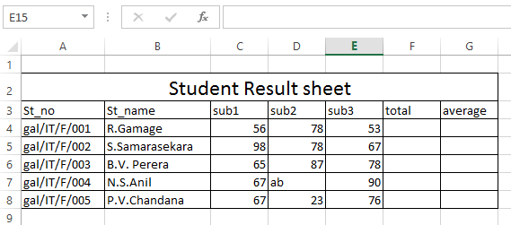
  - Find the total marks of each student
  - Find the average marks of each student
  - Find the maximum and minimum values of each subjects.
  - Find the number of students participate for each subject.

